27.5: See figure on next page. Let 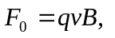then:
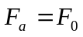 in the 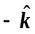 direction
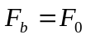 in the 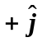 direction
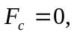 since and velocity are parallel
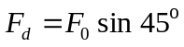 in the 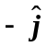 direction
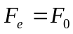 in the 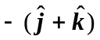 direction
